User Manual

Colorado Risk Limiting Audit Tool v1.0.0 alpha-2

2017

Table of Contents

Introduction 1

Overview of Risk Limiting Audits with the RLA Tool 2

Limitations of the Current Version 2

Basic Functions 2

Launching and Logging In 2

Navigation 6

Setting Up the Audit 7

State Definition of Audit 7

County File Uploads 9

Selection of Contests 10

Random Seed 10

Audit Definition Review 11

Auditing 12

Audit Rounds 12

County Audit Board Activity 12

Monitoring the Audit in Progress 17

Monitoring on the State Site 17

Monitoring on the County Site 20

Exports and Reports 20

Glossary 21

# Introduction

This User Manual provides an overview of the components that comprise the Colorado Department of State (CDOS) Risk Limiting Audit Tool (RLA Tool). It contains screenshots of every page users experience. It also contains a glossary of relevant terms. This RLA Tool represents the cutting edge in efforts to provide verifiable evidence that election results are accurate, and November 2017 is the first time any state has implemented them on a wide scale basis.

## Overview of Risk Limiting Audits with the RLA Tool

The RLA Tool is a computer system, installed on computer infrastructure managed by the Department of State. The system provides a web interface, accessible in a web browser via a url determined by the Department of State. Recommended browsers include Firefox, Chrome and Safari.

Once the Secretary of State uses the RLA Tool to establish a risk limit and designate contests to guide the audit, counties use the RLA Tool to upload verified ballot manifests and cast vote records (CVRs) files that they have exported from their Election Management Systems. The RLA Tool uses this data to determine the random ballot cards to audit, using the risk limit and the margins of victory in the selected contests as a guide for what constitutes a quality audit.

The RLA Tool reports this information to each county via County Dashboard. Within the County, an Audit Board, consisting of representatives of different political parties, working with county administrators, physically retrieves the randomly chosen ballot cards and record their interpretations of voter intent in the RLA Tool. Randomly selected ballot cards are presented to County Audit Boards until either the risk limit is satisfied or the Secretary of State indicates that a full hand count is required.

Complete audit results and artifacts allowing the public to check, independently, that the audit was carried out correctly are exported from the RLA Tool for import to a Public Audit Center hosted on the official CDOS website.

## Limitations of the Current Version

In the current version of the RLA Tool, all contests are considered to be single-county contests. For example, in the context of the audit, the contest for votes for US Senator in Boulder County has nothing to do with the contest for US Senator in Pueblo County (even though in the real world the winner of the US Senate race is determined by combining vote totals from all Counties).

# Basic Functions

## Launching and Logging In

To launch the RLA Tool, point a web browser to the URL provided by the Colorado Department of State. On this page authorized users can enter their login credentials to access the RLA Tool Dashboards.

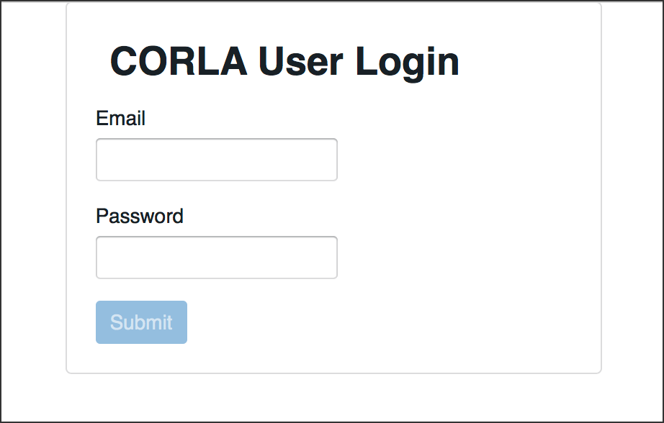

Login

Successful entry of username and password will lead to a two-factor authentication grid challenge.

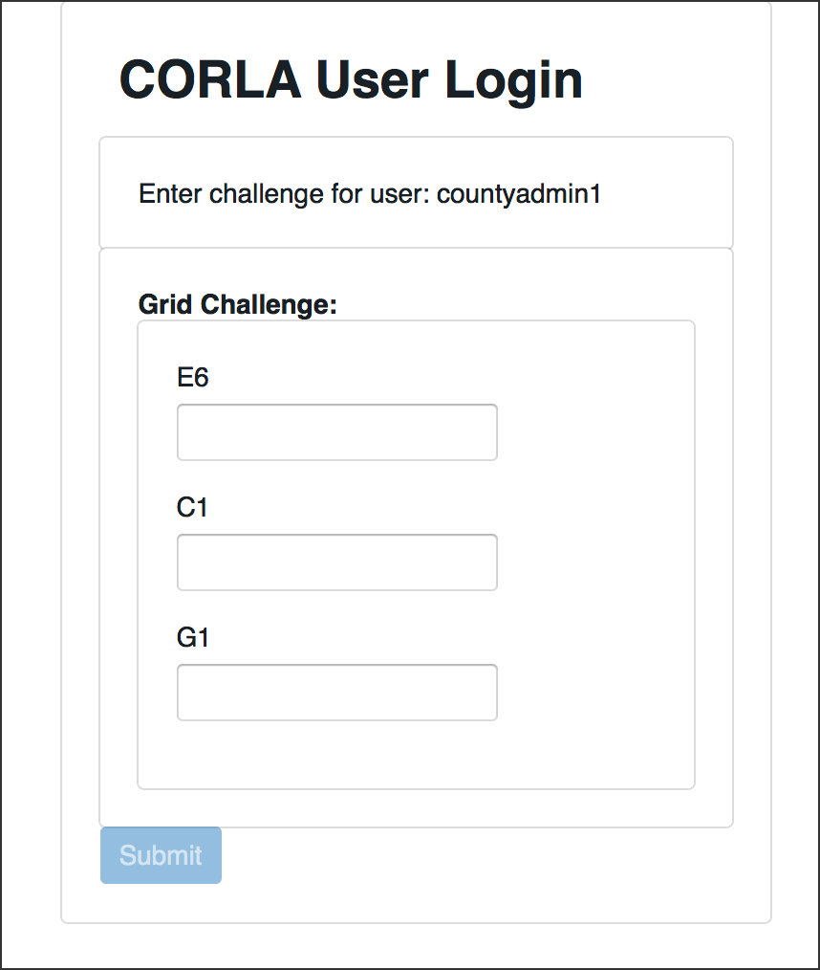

Grid Challenge

After two-factor authentication, users associated with the Department of State will see the Department of State home page.

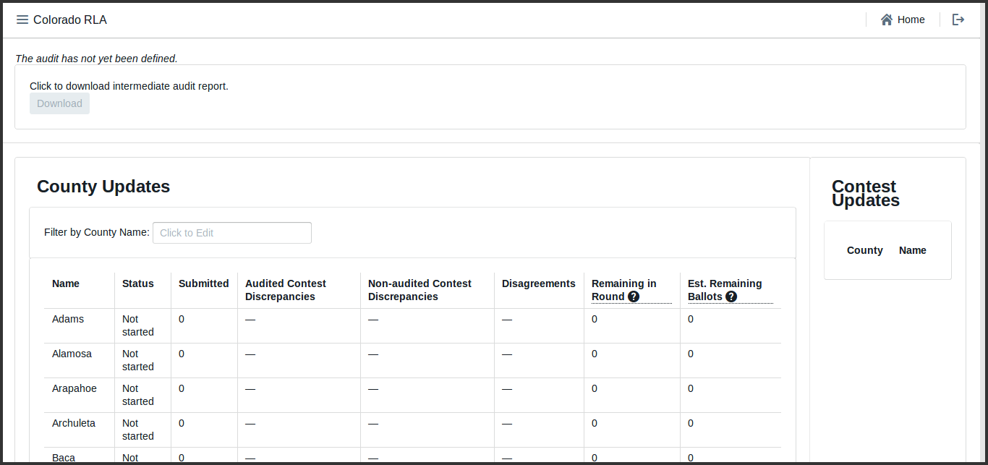

Secretary of State Home Screenshot

Authenticated users associated with a County see a home page tailored to that County.

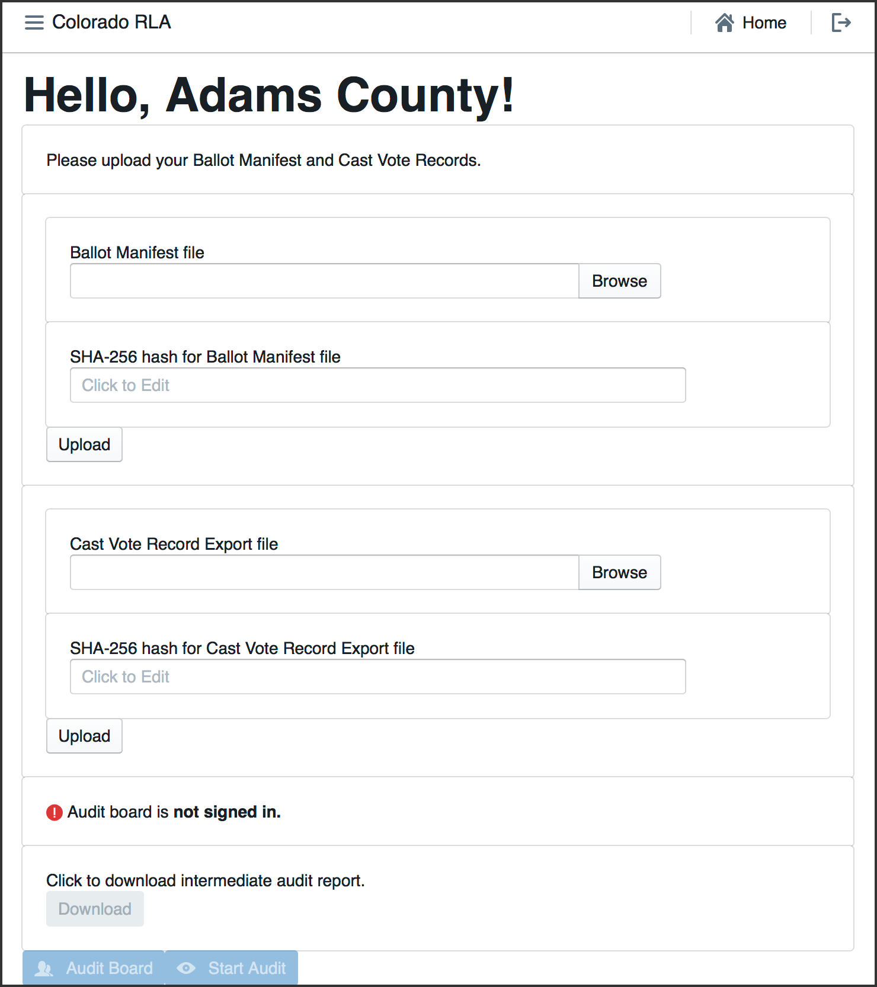

County Home Screenshot

## Navigation

In the upper left corner of every page the site has a navigation icon. Click on the navigation icon to bring up the navigation menu.



Navigation Icon

In the upper right corner of each page is a button to return to the Home Page



Home Button

and a button to log out of the system altogether.



Logout Button

# Setting Up the Audit

## State Definition of Audit

To define the audit -- to specify the risk limit and other choices -- a State user navigates to the Define Audit section. On this page, the user can enter the date of the election, the type of election, the date of the public meeting to choose the random seed and the risk limit.

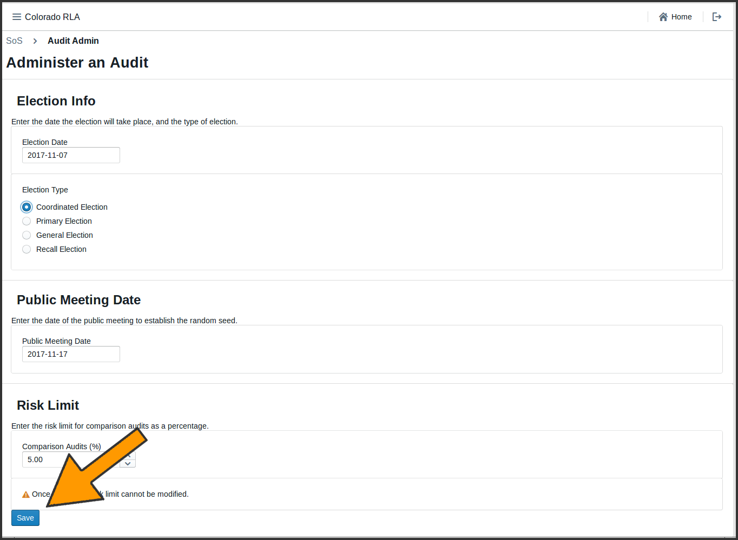

Audit Definition

These choices are summarized on the next page.

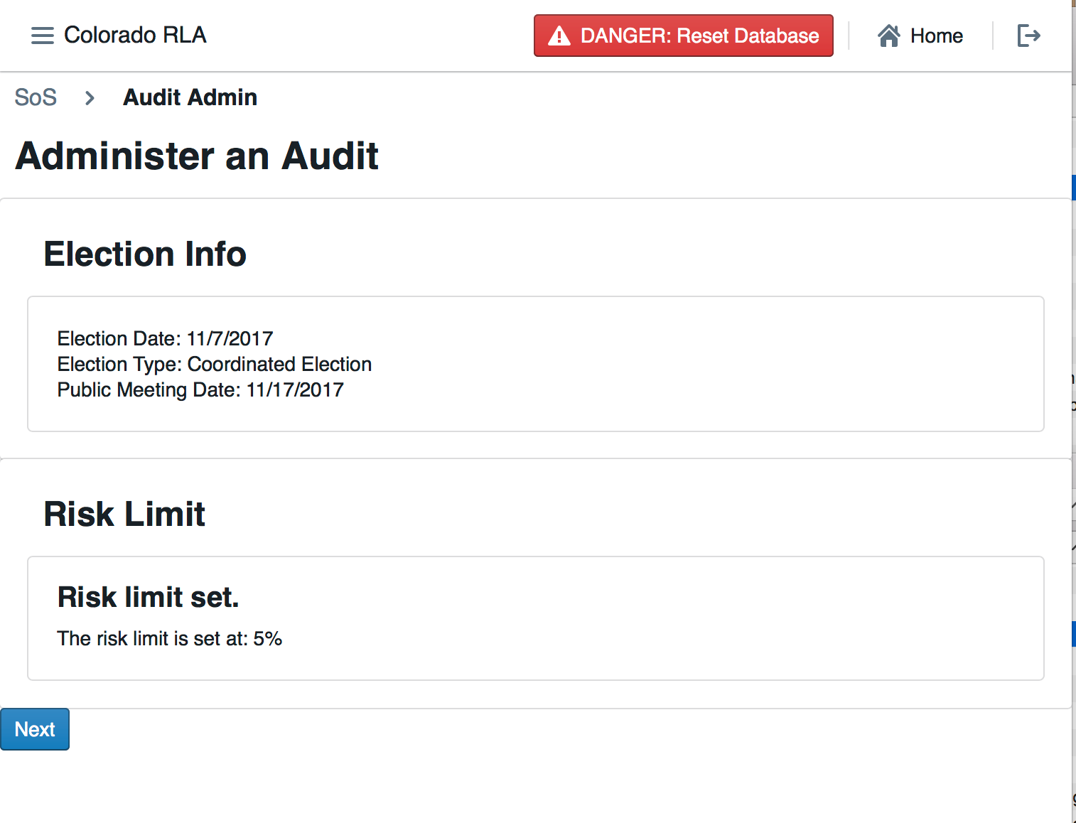

Audit Definition Summary

## County File Uploads

On the County Home page County officials upload their hashed verified Ballot Manifest and CVR files. The purpose of the hashing is to detect transmission errors. The files travel over the internet from the County Board of Election to the Department of State. Before sending a file, the County must enter into the RLA Tool interface a string of numbers and letters (called a "hash") calculated on the file via the Secure Hash Algorithm 256 ("SHA-256" designed by the National Security Agency and freely available to the public). When a file arrives at the Department of State's computer, the RLA Tool calculates the SHA-256 hash of the file. If the file has been changed during transmission, the hash calculated by the Department of State will not match the hash entered by the County, the error will be detected by the system and the County will re-upload the file.

This version of the RLA Tool recognizes and accepts files exported from the Dominion Democracy Suite. The Dominion cast vote record export must be redacted to remove the CountingGroup column.

## Selection of Contests

The Secretary of State will then select the contests that will drive the sample size and stop/go decisions for each round. Rule 25 calls these "contests to be audited".

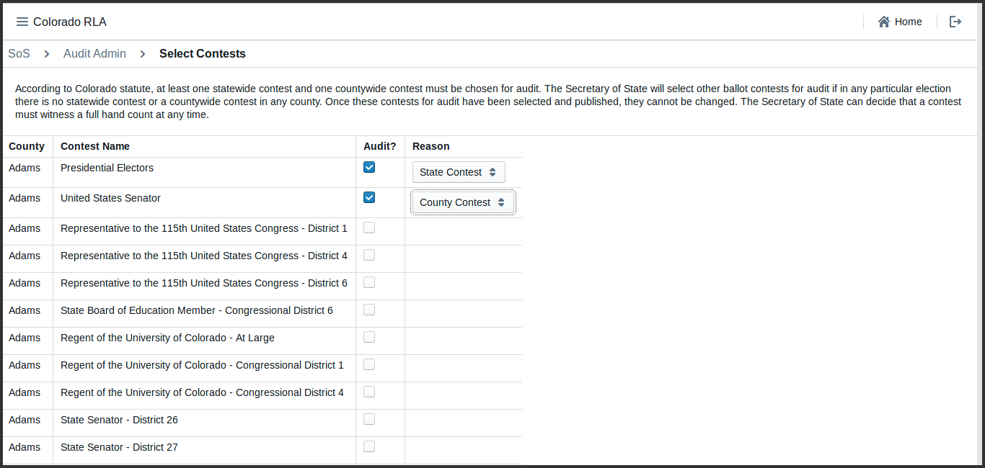

Contest Selection

## Random Seed

After all Counties have uploaded the required files, the Department of State holds a public meeting to determine the random seed for the selection of ballot cards to audit. Once a State user enters the random seed into the RLA Tool, which determines the random sequence of ballot cards (with replacement) using the Pseudo-Random Number Generator using SHA-256 cited in Rule 25.

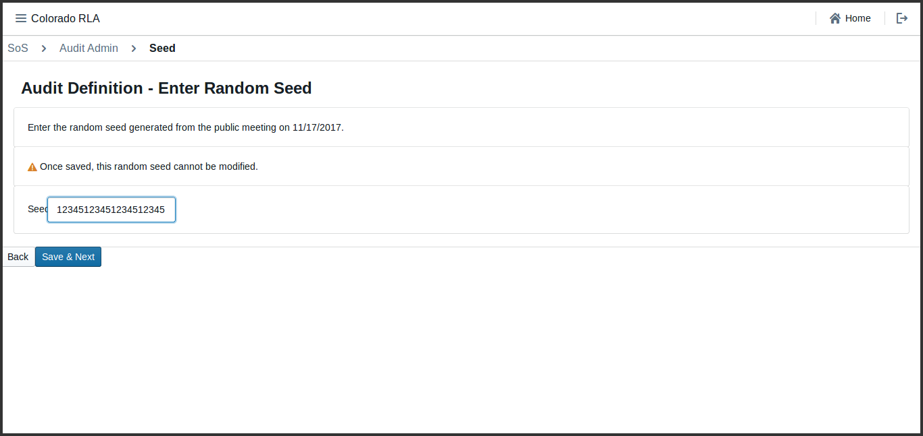

Random Seed Entry

## Audit Definition Review

This page allows the Secretary of State to review the audit data which will be used to define the list of ballot cards to audit for each county.

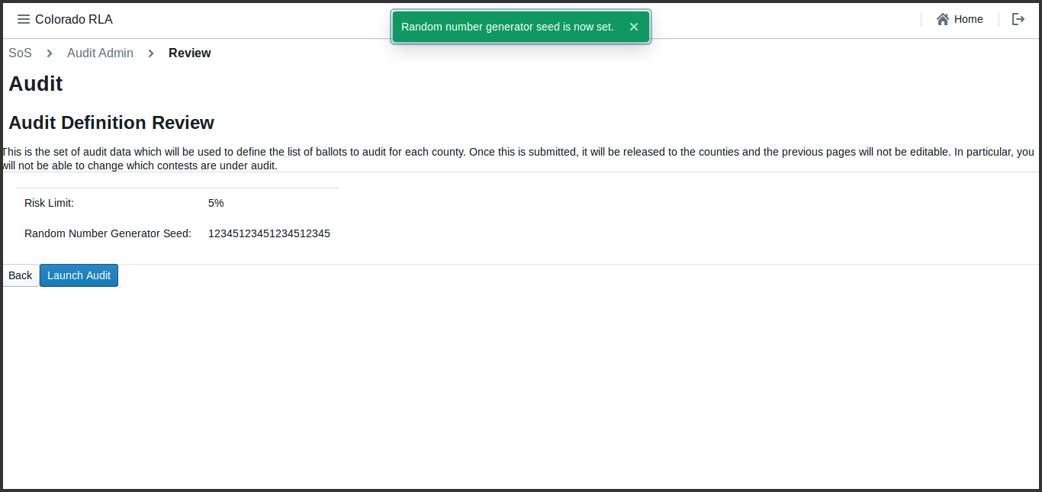

Random Seed Review

# Auditing

## Audit Rounds

The audit is organized into rounds. The first round begins when the Secretary of State launches the audit. The RLA Tool gives lists each County a list of ballot cards to be reviewed by the County Audit Board. As the Audit Boards proceed, the Secretary of State can monitor progress.

When each County Audit Board has reviewed all assigned ballot cards and certified its review, the Secretary of State will have the option to begin the next round.

Once the audit is launched, the first round of the audit begins. In each round, the tool shows each County a list of ballot cards to be reviewed. As the County Audit Boards review ballot cards and enter interpretations, the Secretary of State can see the number of ballot cards reviewed so far, the number of ballot cards with discrepancies (between audit board interpretations and the CVR file), the number of ballot cards on which the audit board disagreed, and the number of ballot cards yet to be reviewed in the current round in the County Update table.

At the end of each round, if the Risk Limit has not been met yet, the Secretary of State can launch the next round.

## County Audit Board Activity

The Audit Board does not log directly into the RLA Tool with usernames and passwords. However, whenever the Audit Board begins to interact with the RLA Tool, either at the beginning of an audit round or after taking a break, there is an informal sign-in process. Note that all audit board members must input first and last names as well as party affiliation. If an audit board member has only a single name, include it as they normally would on any digital input form and put "N/A" in the unused field.

After the Audit Board has signed in, the Audit Board Screen will show the names and party affiliations.

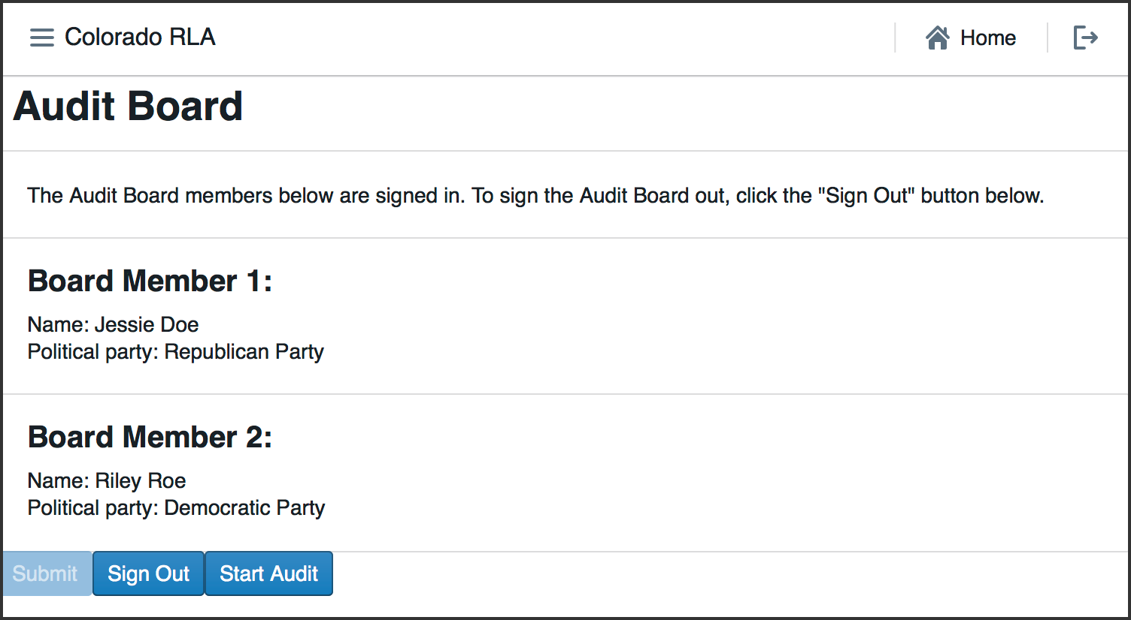

Audit Board Identity

After the Audit Board has signed in, they can use the RLA Tool to review ballot cards. If there is a round in progress for the County, the user will see a list of ballot cards to be audited in the current round. The list includes the Scanner, Batch, and Ballot Position numbers, and (if available) the Storage Bin. As the round progresses the rightmost column will contain check marks for ballot cards that have been reviewed.

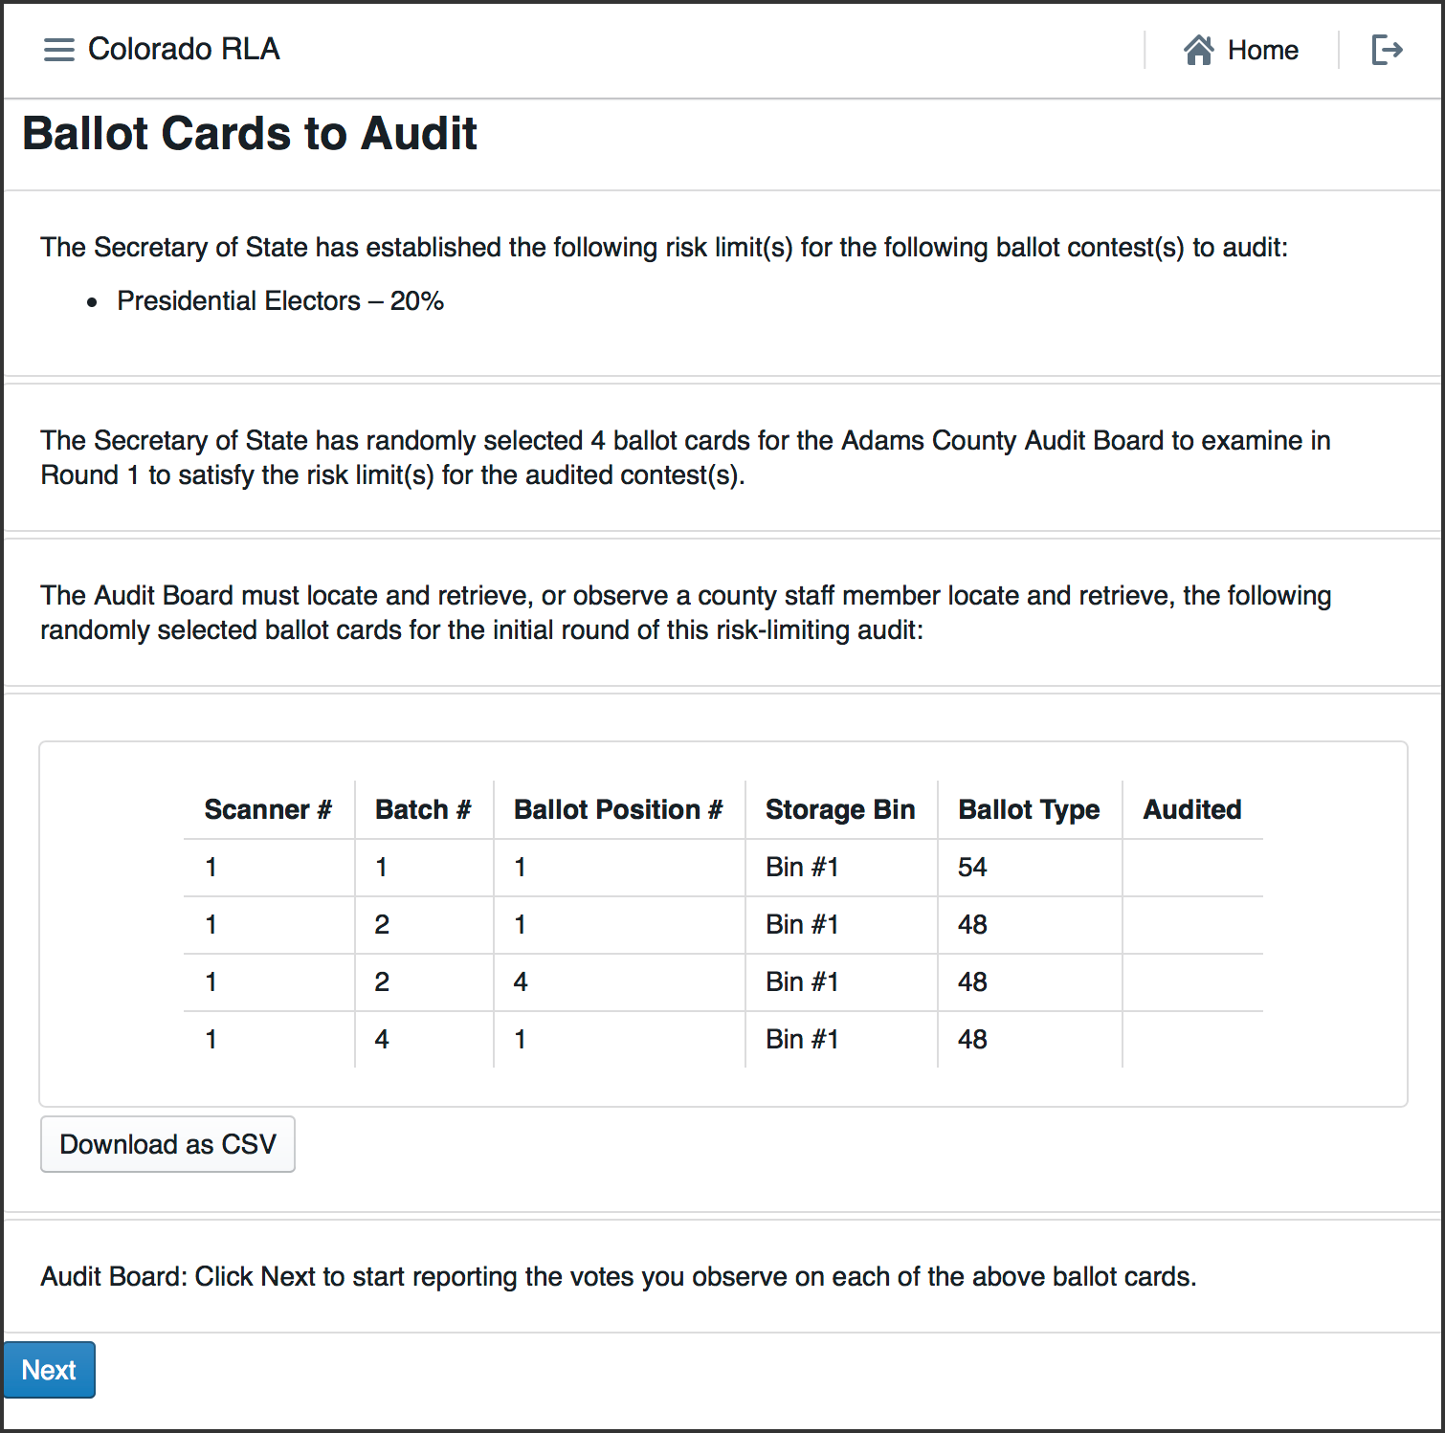

Ballot Cards to Audit

This page has a button to download a csv file that can be saved or printed, containing the list of ballot cards.

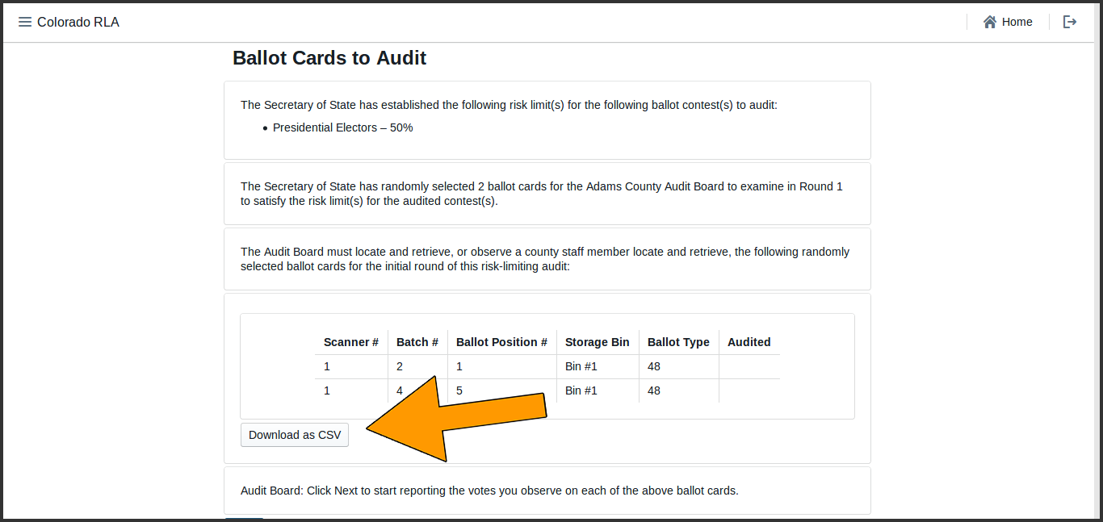

Download CSV

Once the ballot cards have been retrieved, Audit Board members can report the markings on each individual ballot card. .

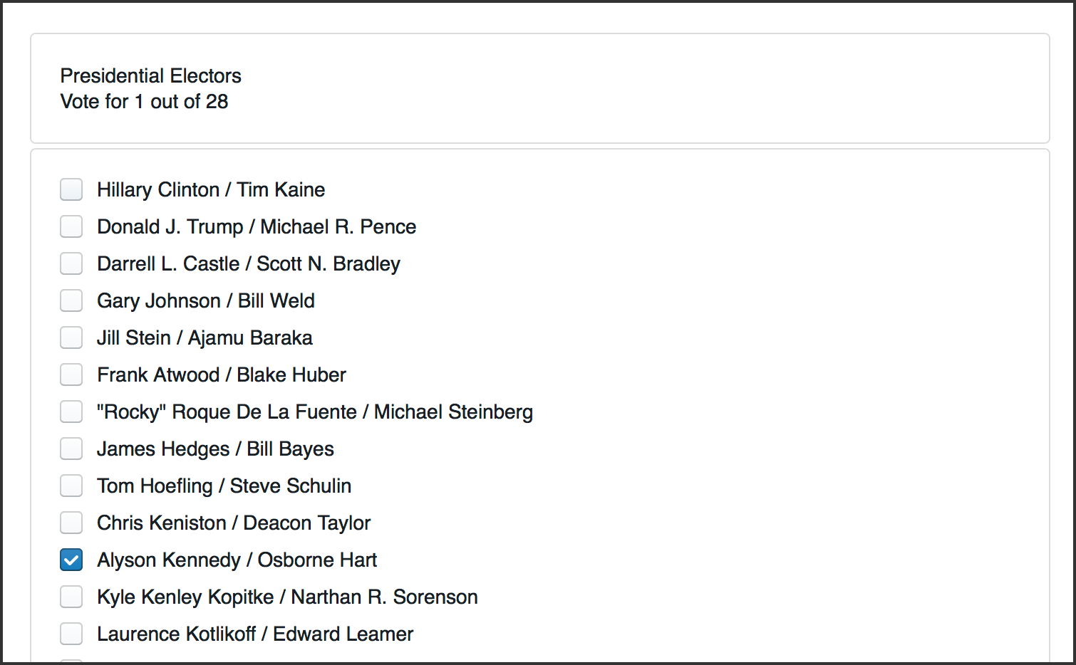

Recording Voter Intent

After entering the interpretation of the markings from any one ballot card, the Audit Board uses the Review screen to check that the information shown reflects the Audit Board's interpretation of the contests on the ballot card. After the review, the Audit Board submits this interpretation and the RLA Tool presents contests from the next ballot card.

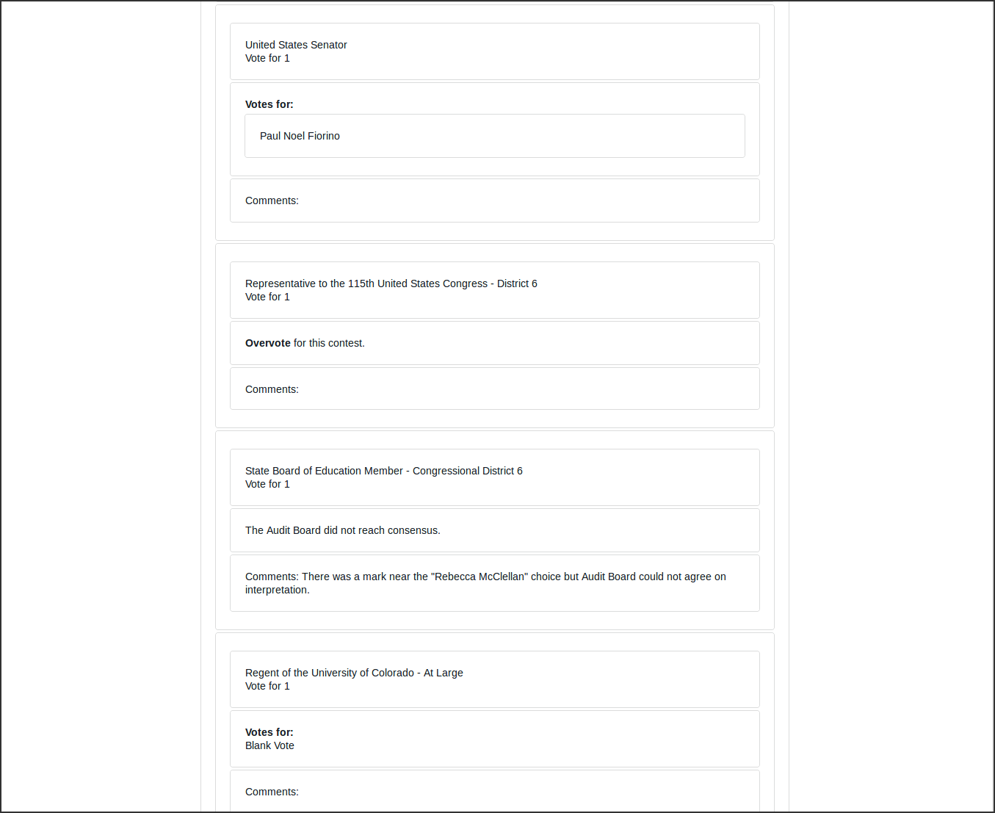

Review Screen

After the last ballot card has been reviewed, the Audit Board is asked to certify the round.

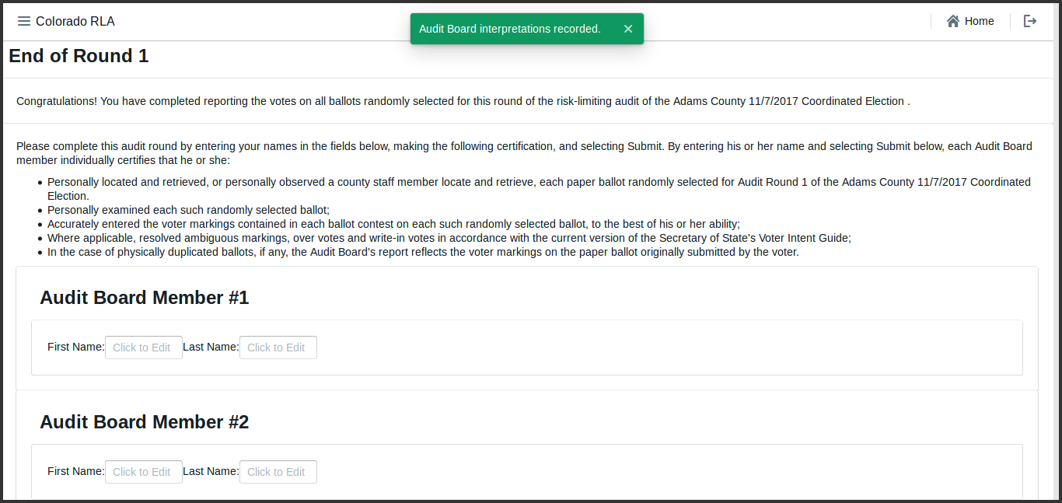

Certification

After certification, until a new round starts, the end of round page appears.

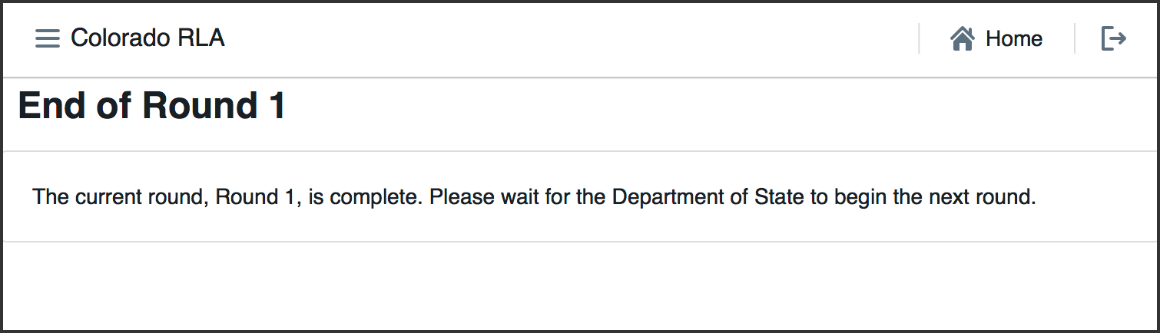

End of Round

## Monitoring the Audit in Progress

While the audit is in progress, both the State and the Counties can see overviews of the status.

### Monitoring on the State Site

On the State home page, in addition to the risk limit and the random seed  
there is a brief statement of the status of the round.

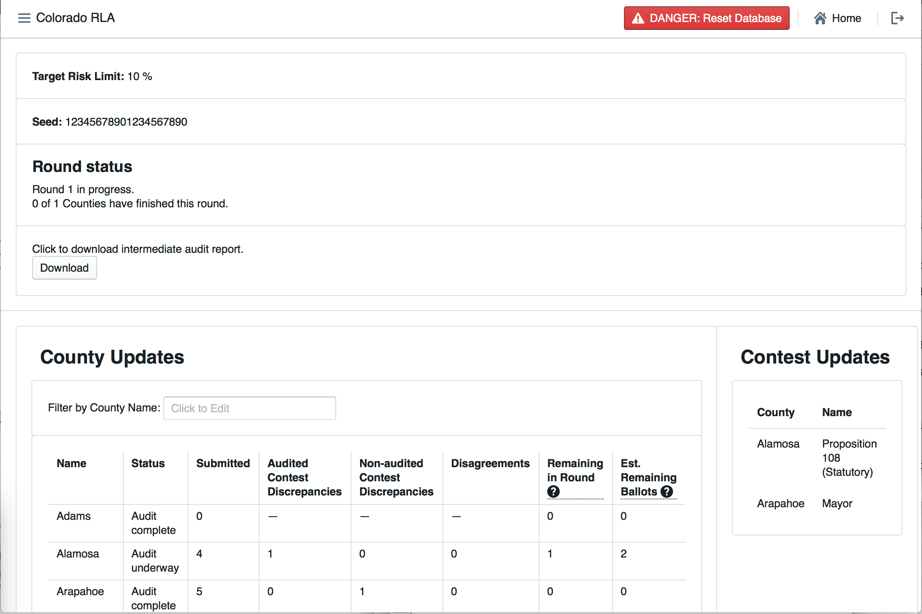

State Home Page Mid-Round

The State home page also has a detailed County Update table and a list of the contests that have been chosen to drive the audit.

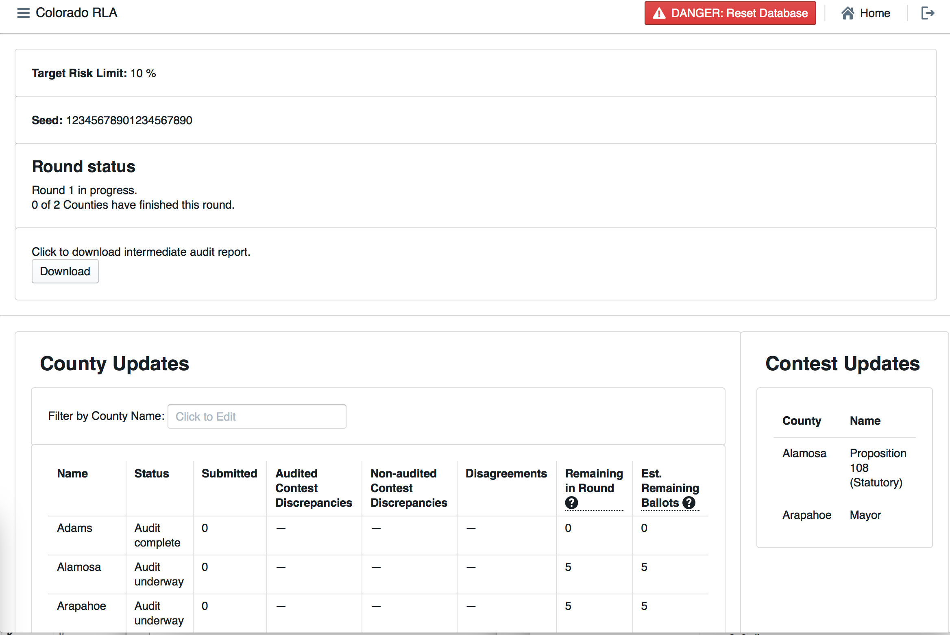

County Update and Contest Update Tables at Start of Round 1

The County Update Table has several columns.

* Status - The Status of the County's audit   
 * Submitted - The number of ballot cards already reviewed by the Audit Board  
 * Audited Contest Discrepancies - the number of cast vote records whose corresponding ballot card either could not be found, or contains at least one race selected for audit for which the Audit Board's interpretation differs from the cast vote record  
 * Non-audited Contest Discrepancies - the number of cast vote records whose corresponding ballot card either could not be found, or contains at least one race not selected for audit for which the Audit Board's interpretation differs from the cast vote record   
* Disagreements - the number of ballot cards on which the Audit Board could not come to consensus in at least one race  
* Remaining in Round - the number of ballot cards remaining for the Audit Board to review in order to complete the current round  
* Est. Remaining Ballots - the estimated size of the statistical random sequence of cast vote records that will be required to finish the audit (with duplicates) minus the size of the longest prefix of that sequence consisting of cast vote records whose corresponding ballot cards have already been reviewed by the Audit Board.

### Monitoring on the County Site

While the audit is on-going, the County Info table shows how many ballot cards are required for the current round, and how many have already been audited. The number of "disagreements" is the number of ballot cards on which the Audit Board could not come to complete consensus. The number of "discrepancies" is the number of ballot cards where the Audit Board's interpretation differs from the interpretation in the uploaded CVR file, or where the ballot card in question could not be found.

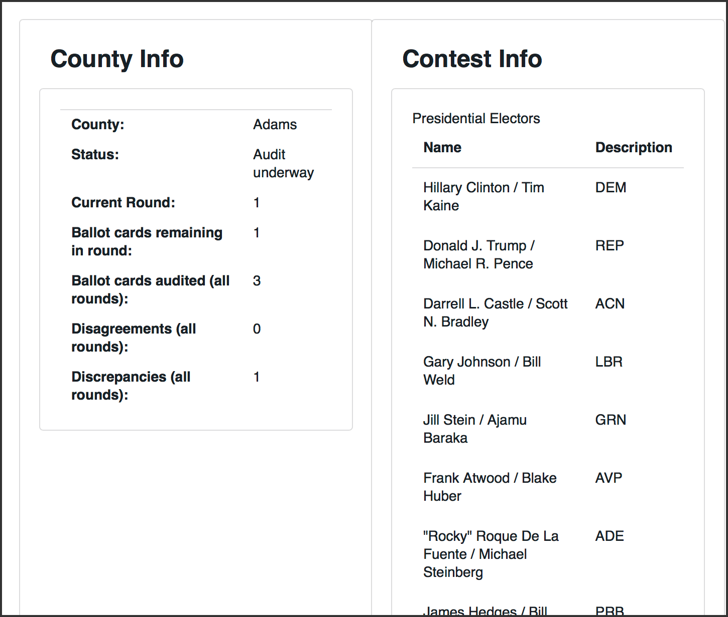

County Home Page During Audit

# Exports and Reports

From the County Home page, depending on the status of the audit, a County can download an intermediate or final audit report.

# Glossary

See also the working documents at [VVSG-Interoperability Voting Glossary](http://collaborate.nist.gov/voting/bin/view/Voting/Glossary) and the glossary in: ["Risk-Limiting Post-Election Audits: Why and How"](https://www.stat.berkeley.edu/~stark/Preprints/RLAwhitepaper12.pdf)

* **RLA Tool** A computer system for conducting a Risk Limiting Audit
* **business interruption** - Any event that disrupts Contractor’s ability to complete the Work for a period of time, and may include, but is not limited to a Disaster, power outage, strike, loss of necessary personnel or computer virus.
* **closeout period** - The period beginning on the earlier of 90 days prior to the end of the last Extension Term or notice by the State of its decision to not exercise its option for an Extension Term, and ending on the day that the Department has accepted the final deliverable for the Closeout Period, as determined in the Department-approved and updated Closeout Plan, and has determined that the closeout is complete.
* **deliverable** - Any tangible or intangible object produced by Contractor as a result of the work that is intended to be delivered to the State, regardless of whether the object is specifically described or called out as a “Deliverable” or not.
* **disaster** - An event that makes it impossible for Contractor to perform the Work out of its regular facility or facilities, and may include, but is not limited to, natural disasters, fire or terrorist attacks.
* **key personnel** - The position or positions that are specifically designated as such in this Contract.
* **operational start date** - When the State authorizes Contractor to begin fulfilling its obligations under the Contract.
* **other personnel** - Individuals and Subcontractors, in addition to Key Personnel, assigned to positions to complete tasks associated with the Work.
* **start-up period** - The period starting on the Effective Date and ending on the Operational Start Date.
* **ballot manifest** - A document that describes how ballot cards are organized and stored, and relates a Cast Vote Records to the physical location in which the tabulated ballot card is stored. The ballot manifest specifies the physical location of a ballot card to allow staff to find the specific ballot card represented by a given CVR. A ballot manifest will contain the following information: county ID, tabulator ID, batch ID, the number of ballot cards in each batch, and the storage location where the batch is secured following tabulation. A sample ballot manifest is provided at [manifest-dq.csv](samples/manifest-dq.csv)
* **cast vote record (CVR)** - An electronic record indicating how the marks on a ballot card were interpreted as votes. May be created by a scanner or DRE, or manually during an audit. Sample CVRs in Dominion's format are in test/dominion-2017-CVR_Export_20170310104116.csv. See also [VVSG-Interoperability CVR Subgroup](http://collaborate.nist.gov/voting/bin/view/Voting/BallotDefinition).
* **contest** - Any decision to be made by voters in an election, such as a partisan or nonpartisan candidate race, or a ballot measure. Ex: Jane Doe for Colorado Secretary of State. Each option for the voter is called a *choice*.
* **choice** Any possible outcome of a Contest. In a Contest to determine who will fill a certain office, each choice is a person, called a candidate for the office. In a ballot question contest, the choices are "Yes" and "No".
* **coordinated election** - Coordinated Elections occur on the first Tuesday of November in odd-numbered years. If the Secretary of State certifies at least one statewide ballot measure to the counties, every county will conduct the Coordinated Election, and the vast majority of counties will include additional local ballot content in the election. If the Secretary of State does not certify at least one statewide ballot measure to the counties, then only those counties to which local political subdivisions certify ballot content will conduct a Coordinated Election in that year.
* **county administrator** - The designated representative(s) of each county clerk and recorder who possesses RLA administrative user privileges sufficient to upload a cast vote record and ballot manifest for the county.
* **contest name** - The title of a contest.
* **election day** - The final day on which voters can cast a ballot in a State Primary Election, Presidential Primary Election, Coordinated Election, or General Election.
* **offeror** - A vendor that submits a responsible bid for this Documented Quote.
* **pseudo-random number generator** - A random number generator application that is further explained at http://statistics.berkeley.edu/~stark/Java/Html/sha256Rand.htm Test data is available at https://github.com/cjerdonek/rivest-sampler-tests
* **random seed** - A random seed (or seed state, or just seed) is data, such as a number, vector or string, used to initialize a pseudorandom number generator.
* **responsible bid** - A bid from a vendor that can responsibly (i.e. is reasonably able and qualified) do the work stated in the solicitation.
* **risk-limiting audit (RLA)** - A procedure for manually checking a sample of ballot (cards) (or other voter-verifiable records) that is guaranteed to have a large, pre-specified chance of correcting the reported outcome if the reported outcome is wrong. (An outcome is wrong if it disagrees with the outcome that a full hand count would show.) One paper describing risk-limiting audits is located at https://www.stat.berkeley.edu/~stark/Preprints/gentle12.pdf.
* **state administrator** - The designated person who possesses RLA administrative user privileges to perform administrative tasks.
* **tabulation** - Aggregation of tallies of interpretations of voter choices into election results. @review NIST Election Modeling group separates interpretation, tally and tabulation.
* **tabulated ballots** - Paper ballot cards that have been scanned on a ballot scanning device, and the voter markings on which have been interpreted by the voting system as valid votes, undervotes, or overvotes. Tabulated ballots may be duplicates of original ballots. @review this means ballots counted by hand weren't "tabulated". Is that what we want to say?
* **two-factor authentication** - Defined as two out of the three following requirements:
* Something you have (Examples: token code, grid card)
* Something you know (Example: passwords)
* Something you are (Example: biometrics)
* **ENR system** An Election Night Reporting system, a computer system enabling publication of election results starting on election night, and continuing through the end of certification.
* **reported outcome** - The set of contest winners published by the ENR system.
* **calculated outcome** - The set of contest winners according to the CVRs that are being audited.
* **wrong outcome** - When the reported outcome for a given contest does not match the outcome that a full hand count of the paper ballots would show. This can happen due to equipment failures, adjudication errors, and other reasons.
* **full hand count** - TBD along these lines: A procedure for determining the correct outcome of a contest, suitable for use in an RLA. It involves a tabulation of the votes for each choice in a contest which involves manual interpretation of each ballot, and may involve verifiable machine assist with checking the counts. See one suggested procedure at [Branscomb full hand countproposal](http://www.sos.state.co.us/pubs/rule_making/written_comments/2017/20170718BranscombMcCarthy.pdf). Cf. *recount*.
* **recount** TBD, a procedure under Colorado law that happens *after* certification if the margin is too tight, or if a candidate requests it. A recount doesn't have to involve manual interpretation of each ballot. Cf. *full hand count*.
* **overstatement of the margin** An error whose correction reduces the margin https://www.stat.berkeley.edu/~stark/Preprints/evidenceVote12.pdf
* **understatement of the margin** An error whose correction increases the margin https://www.stat.berkeley.edu/~stark/Preprints/evidenceVote12.pdf
* **evidence-based elections** - An approach to achieving election integrity in which each election provides affirmative evidence that the reported outcomes actually reflect how people voted. This is done via software-independent voting systems, compliance audits and risk-limiting audits. An alternative to certifying voting equipment and hoping that it functions properly in real elections. See also *resilient canvass framework*. See [Evidence-Based Elections - P.B. Stark and D.A. Wagner](https://www.stat.berkeley.edu/~stark/Preprints/evidenceVote12.pdf)
* **resilient canvass framework** - A fault-tolerant approach to conducting elections that gives strong evidence that the reported outcome is correct, or reports that the evidence is not convincing. See also *evidence-based elections*.
* **compliance audit** - An audit which checks that the audit trail is sufficiently complete and accurate to tell who won. Generally includes poll book accounting, ballot accounting, chain of custody checks, security checks, signature verification audits, voter registration record auditing, etc. Related terms include election canvass, ballot reconciliation. See https://www.stat.berkeley.edu/~stark/Preprints/evidenceVote12.pdf
* **audit board** - Given a County, a group of electors in the county nominated by the major party chairpersons, which carries out an audit, with the assistance of the designated election official, members of his or her staff, and other duly appointed election judges.
* **audit** A process by which the performance or outcome of a system is verified. @review TBD May include ballot tabulation audits, compliance audits, ...
* **RLA** Risk Limiting Audit
* **Risk Limiting Audit** An Audit designed to reduce the statistical probablility that a wrong election winner was determined by an interpretation and tabulation system.
* **ballot tabulation audits** An Audit of a vote-tabulation system. @review TBD. including risk-limiting audits, opportunistic audits, bayesian audits, fixed-percentage audits, etc. @review if we honor the NIST Election Modeling Group distinction between interpretation and tabulation, this definition describes a "ballot interpretation and tabulation audit"
* **opportunistic audit** - An auditing technique designed to efficiently generate evidence for additional contests in a ballot-level audit. A significant part of the effort in doing a risk-limiting audit involves physically retrieving the ballots selected for audit. While doing the manual tabulation and entering the data for the contests on that ballot which are subject to strict risk limits, it is possible to "opportunistically" do the same thing for other contests that are observed on the same ballot, producing evidence about them for little additional effort. These are called "opportunistic contests". If an opportunistic contest achieves a risk limit, it can be "settled", and when it appears on subsequent ballots during the audit, it need not be tabulated. TBD: discuss need to consider possibility of sampling bias when evaluating and reporting, considerations for possible escalation, etc.
* **mandatory contest** - A Contest in a Risk Limiting Audit which is subject to a Risk Limit and hence is factored in to the sampling calculations.
* **opportunistic contest** - A contest to be audited opportunistically.
* **Risk Limit Goal** In a Risk-Limiting Audit, each Contest has a Risk-Limit Goal, namely, the acceptable risk that an incorrect outcome will escape notice.
* **Dynamic Risk** In a Risk-Limiting Audit in progress, for any specific Contest Under Audit, at any given time the Dynamic Risk is the probability, based on Ballots audited so far, that an incorrect outcome of the Contest as escaped notice.
* **Under Audit** A Contest that has been chosen for audit.
* **active contest** At any given time, a Contest Under Audit whose Dynamic Risk exceeds the Risk Limit Goal @review this is just a guess @review what's the origin of this term? Couldn't find it in Stark or Lindeman/Stark.
* **settled contest** At any given time, a Contest Under Audit whose Dynamic Risk is less than or equal to the Risk Limit Goal @review TBD involving having achieved Risk Limit Goal. Note need to ensure that calculations take into account the way the samples were selected, in case any samples were taken in a stratified manner or taken non-uniformly in order to target non-county-wide contests.
* **uncontested contest** A Contest for which the number of choices is less than or equal to the number of winners @review Consider a contest with three winners where each voter can vote for two. Are we OK calling that an "uncontested contest"? Or a contest (such as Republican Committeperson in Philadelphia) with a minimum number of votes required for a write-in candidate? And in jurisdictions without qualification or other restrictions on counting write-in votes, how can we be sure that any contest is uncontested?
* **bayesian audits** @review Neal McBurnett
* **voting method** TBD
* **electoral system** the method used to calculate the number of elected positions in government that individuals and parties are awarded after elections.
* **ballot** a list of contests and, for each contest in the list, a list of choices, in a form that allows a person to record choices and allows a person or a computer (or both) to read recorded choices. Each ballot is composed of one or more ballot cards, and each ballot card has a unique ID.
* **ballot card** a single physical page of a ballot.
* **margin** Given a contest and two choices in that contest, the numerical difference between the choice that got more votes and the choice that got fewer votes.
* **hash function** TBD, mentioning specifically SHA-256
* **RLA software** The software component of an RLA Tool.
* **ballot storage bin** A physical container for a set of paper ballot cards.
* **batch** A set of Ballot Cards which has a numeric id and a size (the number of Ballot Cards contained in the batch).
* **batch id** Each Batch has a unique Ballot Identifier.
* **batch size** the size of a batch, and virtually all batches are identically sized.
* **chain of custody** Given an item (e.g., Marked Ballots, Unmarked Ballots, Ballot Cards) in need of security over a certain time period, the chain of custody is the sequence of people, organizations or locations where the item remains secured over the given time period.
* **county** (in the US) a political and administrative division of a state, providing certain local governmental services, including conducting elections.
* **scanner** A machine that can take Paper Ballots as input and whose output is a CVR for each Paper Ballot.
* **imprinted ballot** - A Paper Ballot Card on which a unique Ballot Card identifier has been imprinted in order to facilitate a Ballot Card-level audit. The unique Ballot Card identifier might for instance include a unique Batch Identifier and the sequence of the Ballot Card within the Batch, or it might be a new identifier which is also included in the CVR. Imprinting should be done after the ballot card is cast and with care taken to avoid causing anonymity problems.
* **ballot order** A specific ordering of a set of Ballot Cards.
* **Secretary of State (SOS)** In most states in the United States, an office of government defined in the state constitution.
* **Department of State (DOS)** An agency of government which, in most states of the United States of America, is charged with oversight of state elections.
* **audit report** TBD
* **SOS audit form** TBD
* **ballot certification** TBD
* **UOCAVA voter** A person entitled to cast a UOCAVA Ballot
* **UOCAVA ballot** A certain type of absentee ballot prescribed by the federal Uniformed and Overseas Citizens Absentee Voting Act and codified in 52 USC Ch. 203.
* **mail ballot** A Paper Ballot that may be cast by physical delivery to the Board of Elections, usually via the US Postal Service.
* **election canvass** The process of counting and verifying, or “canvassing,” the various precinct votes and making determinations on the election results.
* **canvass board** The body which conducts the election canvass and certifies the winners of county and local offices, as well as certifies county vote totals for state and federal offices that extend beyond the county limits.
* **post-election (historical, random) audit** Traditional post-election audits typically entail randomly selecting a few precincts or voting machines, and checking the associated results with a hand count of the paper ballots. While these audits do provide some evidence that the machines have correctly interpreted voters’ intent, they audit only a few samples, often using an artificially created subset of results, rather than the actual election results.
* **county clerk** An office of County government, established by the Colorado Constitution (Article XIV, Section 8) and responsible for conducting elections in the County.
* **sample size** TBD including **initial sample size**
* **equipment** TBD
* **VVPAT** - A Voter-Verifiable Paper Trail consists of an audit trail of Voter-Verifiable Paper Records (VVPRs). Elections which produce a VVPAT allow an audit to gather evidence which the voter had an opportunity to verify. The VVPRs may appear in a continuous roll of paper used to provide auditability for a DRE.
* **VVPR** - A Voter-Verifiable Paper Record, also known as a Voter-Verifiable Paper Ballot (VVPB). 'Voter-verified' refers to the fact that the voter is given the opportunity to verify that the choices indicated on the paper record correspond to the choices that the voter has made in casting the ballot. Risk-limiting audits require VVPRs.
* **non-voter-verifiable ballot** (NVVB) - A ballot for which there is no auditable VVPR. For example a ballot sent via an online ballot return system or email, for which the voter has not returned a matching voter verifiable paper ballot. AKA digital ballot.
* **phantom ballot** An entry in the Ballot Manifest for which there is no corresponding Paper Ballot Card. Phantom ballots can represent pancies between the manifest and the actual paper ballot card batches. A manifest with a batch of purely phantom ballots can also be used to represent the maximum number of possibly late-tabluation ballots.
* **late-tabulation ballot** - A ballot which is tabulated after the CVR report and manifest are generated, but before the canvass is finished.
* **duplicated ballot** A Ballot marked by an Election Official by copying voter choices from another Ballot.
* **original ballot** A Ballot from which a Duplicated Ballot has been created.
* **DRE** A voting system whose primary record of voter intent is an electronic record created by a voter's physical interaction with a voting machine.
* **votes allowed** Given a Contest, the maximum number of choices a voter may legitimately select in that Contest.
* **overvote** Given a Marked Ballot and a Contest, a selection of more choices than the Votes Allowed for that Contest.
* **stray mark** A Ballot Mark that does not carry any information about voter intent.
* **damage** TBD
* **undervote** Given a Marked Ballot and a Contest, a selection of fewer choices than the Votes Allowed for that Contest.
* **risk limit** - The pre-specified minimum chance of requiring a full hand count if the outcome of a full hand count would differ from the reported tabulation outcome.
* **voting system** TBD
* **Dr. Philip Stark** Associate Dean, Division of Mathematical and hysical Sciences, Professor of Statistics, University of California. https://www.stat.berkeley.edu/~stark/
* **Dr. Mark Lindeman** Mark Lindeman is a political scientist who studies public opinion and elections. He presently lectures at Columbia University in quantitative methods, and led the revision of Carroll Glynn et al.’s multidisciplinary textbook Public Opinion. https://electionverification.org/aee-statistics-and-auditing/
* **Dr. Ron Rivest** Professor Rivest is an Institute Professor at MIT. He joined MIT in 1974 as a faculty member in the Department of Electrical Engineering and Computer Science. He is a member of MIT's Computer Science and Artificial Intelligence Laboratory (CSAIL), a member of the lab's Theory of Computation Group and a founder of its Cryptography and Information Security Group. He is a co-author (with Cormen, Leiserson, and Stein) of the text, Introduction to Algorithms. He is also a founder of RSA Data Security, now named RSA Security (the security division of EMC), Versign, and Peppercoin. Professor Rivest has research interests in cryptography, computer and network security, electronic voting, and algorithms. http://people.csail.mit.edu/rivest/
* **Colorado House Bill 09-1335** an act of the Colorado Legislature concerning requirements for voting equipment.
* **EAC** An independent, bipartisan commission of the United States Federal Government, established by the Help America Vote Act of 2002.
* **Clear Ballot Group** An election technology company. https://www.clearballot.com/
* **Clear Ballot ClearCount** Clear Ballot Group's browser-based central count tabulation, consolidation and reporting system.
* **OpenCount** OpenCount is a system that can interpret scanned paper ballots and interpret them into cast vote records. It can understand some of the existing proprietary file formats for other vendors’ equipment, and can semi-automatically figure out the shape and nature of a ballot with a little help from an elections official. OpenCount was originally designed and implemented at Berkeley under the guidance of Prof. David Wagner.
* **Dominion** Dominion Voting Systems is an election technology company. http://www.dominionvoting.com/
* **Ballot Retrieval** @review morganmillerux the process of getting the ballots seems like a specific point of concern and merits being called out.